**Total revenue**

1. select SUM(total_price) as Total_Revenue from Tbl_pizza_sales;

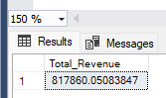

**Average Order Value**

1. select sum(total_price) /count(DISTINCT order_id ) AS Avg_Order_value from tbl_pizza_sales;

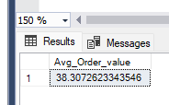

**Total Pizza Sold .**

select sum(quantity) as Total_Pizza_sold from Tbl_pizza_sales;

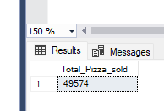

**Total Order Placed**

select count(DISTINCT order_id) as Tatal_order from Tbl_pizza_sales;

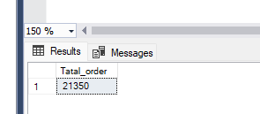

5. **Average Pizza per order.**

select cast(sum(quantity) as decimal(10,2)) / cast(count(distinct order_id) as decimal(10,2)) as AVG_pizza_order from Tbl_pizza_sales;

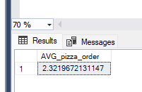

**6. Order day + total order**

select datename(DW, ORDER_DATE) AS Order_day, count(distinct order_id) as Total_order from Tbl_pizza_sales

group by datename(DW, ORDER_DATE);

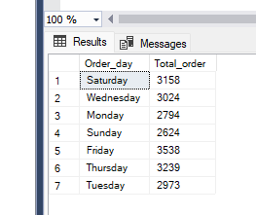

**7. Order per month**

select datename(month, ORDER_DATE) AS Order_Month, count(distinct order_id) as Total_order from Tbl_pizza_sales

group by datename(month, ORDER_DATE) order by total_order DESC;

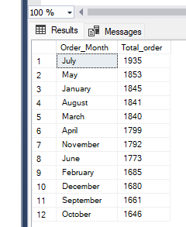

**8. Percentage of total sales by pizza category wise.**

select pizza_category, sum(total_price) AS total_sales, sum(total_price) * 100 / (select sum(total_price)

from Tbl_pizza_sales where month(order_date)= 1) as PCT

from Tbl_pizza_sales where month(order_date)= 1 Group by pizza_category ORDER BY pizza_category;

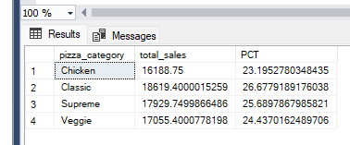

9. **pizza salese paercetage by pizza size wise.**

select pizza_size, sum(total_price) AS total_sales, sum(total_price) * 100 / (select sum(total_price)

from Tbl_pizza_sales where month(order_date)= 1) as PCT

from Tbl_pizza_sales where month(order_date)= 1 Group by pizza_size order by pct ;

**OR**

select pizza_size, sum(total_price) as Total_sales, cast(sum(total_price) * 100 / (select sum(total_price)

from Tbl_pizza_sales) as decimal(10,2)) as PCT FROM Tbl_pizza_sales GROUP BY pizza_size order by PCT DESC;

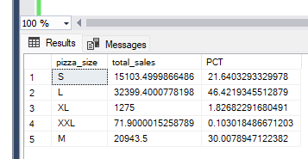

**10. Top 5 pizza sales by Pizza name & Revenue.**

select top 5 pizza_name,sum(total_price) as Total_Revenue from Tbl_pizza_sales group by pizza_name order by Total_Revenue desc;

